RxImage Image Layouts

The RxImage pill images have 8 different layouts. The layouts are specified in the <Layout> or <Class> tag in the XML (each image will have one, but not both of the tags). The following are examples of each type of layout.

# MC_API_NLMIMAGE_V1.3

This is an image returned by the RxImage API. The image does not contain any metadata.

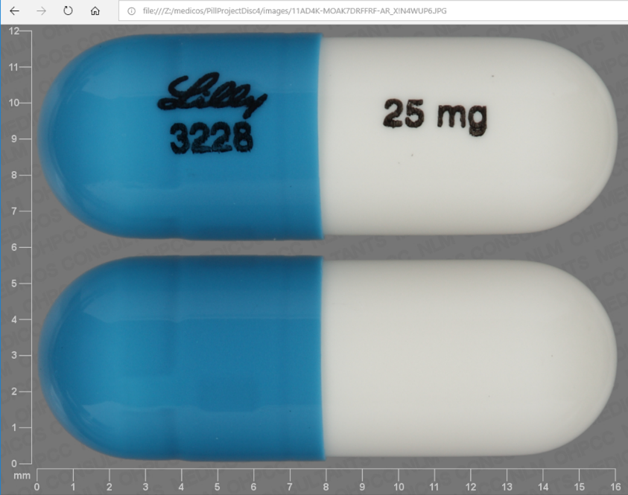

# MC_API_RXNAV_V1.3

This is an image returned by the RxImage API. The image contains metadata.

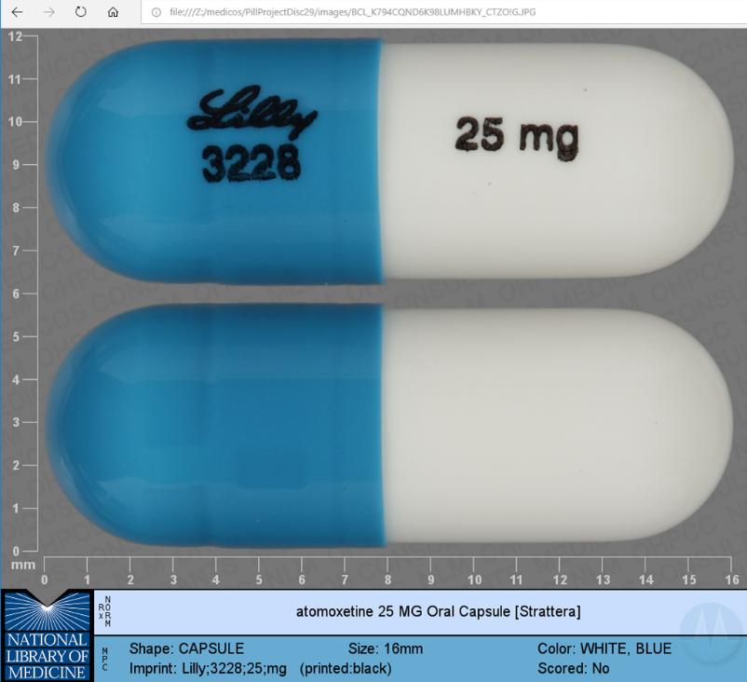

# MC_C3PI_REFERENCE_SEG_V1.6

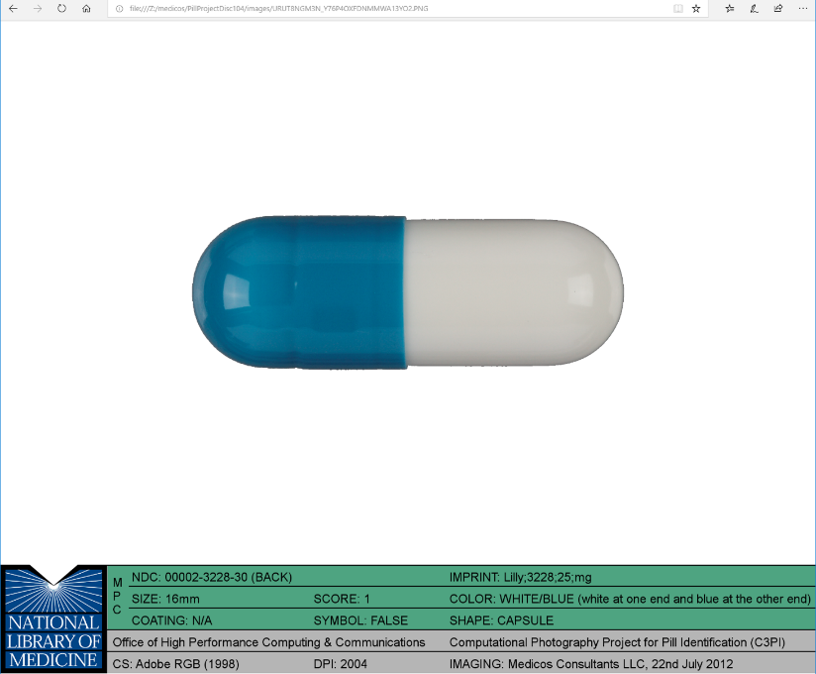

# MC_CHALLENGE_V1.0

This is an image used in the NLM pill challenge contest.

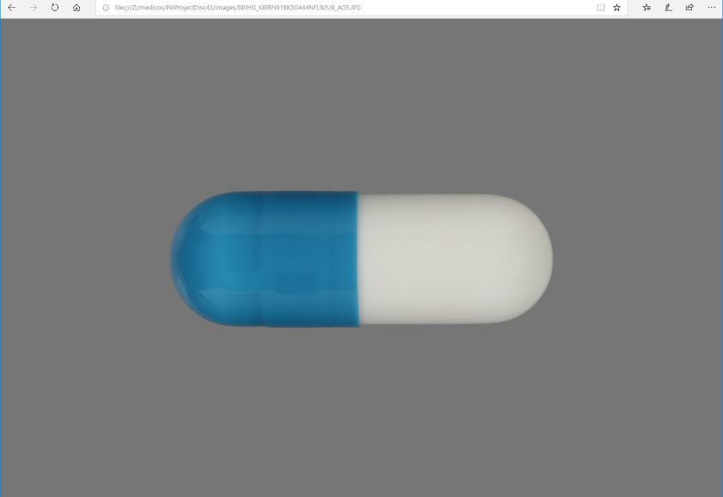

# MC_COOKED_CALIBRATED_V1.2

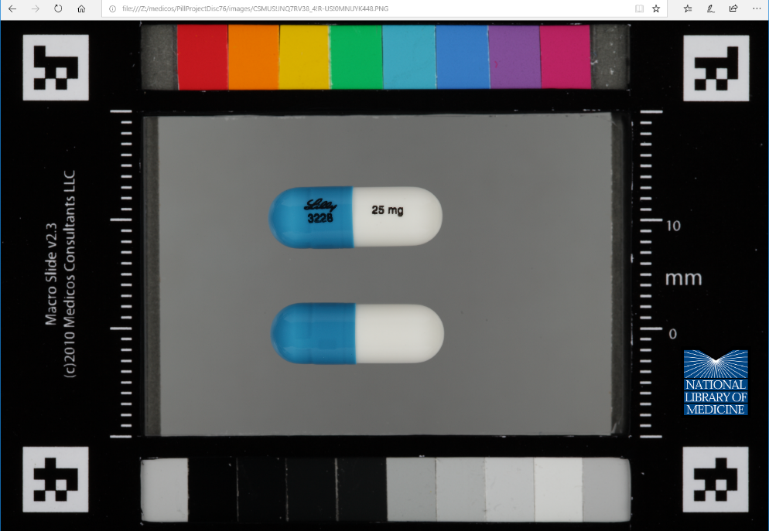

# MC_SPL_IMAGE_V3.0

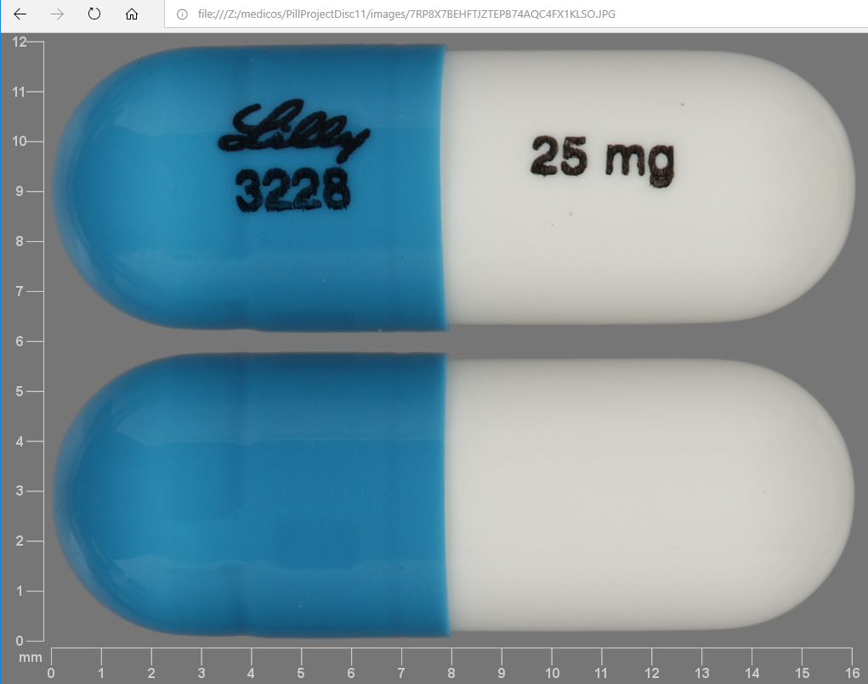

# C3PI_Reference

The image file has a .CR2 extension.

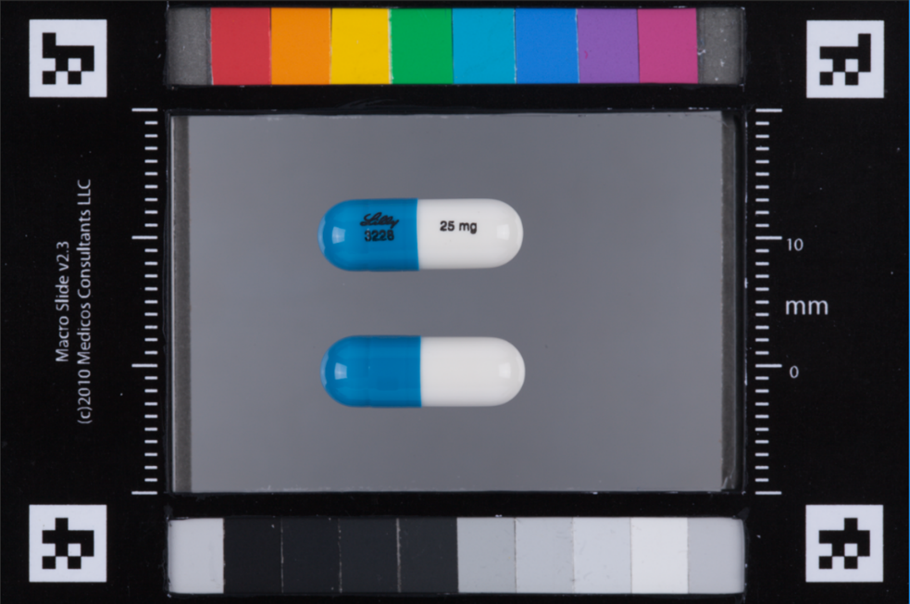

# C3PI_Test

This is a test image. Background and lighting can vary from image to image.

